The 2014 Irish Open report:
Venue: Beresford Hotel, Dublin, Dublin 1. Sat 25th – Sun 26th- Mon 27th. October
This is considered by many draught players as one of the Grand slam events in Europe. The other 3 being the Northern Ireland Open, Scottish Open , and Welsh Open .
The British Open, English Open are also included but are played for every two years.
So it appears we have a wealth of 1st class draughts ty’s.
As playing venues go this was an excellent venue, very much centrally located with direct and easy access from Dublin airport and train and bus transportation.
The playing room itself was self contained and the uniform playing boards and clocks that the Irish association have acquired were easy on the eye, and showed an air of professionalism. The event was opened with an address from chairman Joe Maguire, welcoming all the players. Then on the Sunday the Lord Mayor of Dublin paid a visit and gave a welcome which was both simple and direct, showing a knowledge of what our ty was all about, most welcome indeed.
Ten times world champion Ron King (Barbados), Igor Martynov and Filipe Kareta (Czech Republic), Ken Lovell (England), John Morgan (Wales), also a very strong Scottish contingent: Colin Young, Danny Oliphant, Graham Young, Keith Fourbister, were most welcome visitors to our shores.
Ty controllers were Jim Summners and Peader Sweeney and had three sections to control. Masters (19 players), Senior (14 players) & Inter (7 players). With a total of 40 players this was indicative of a lot of hard work behind the scenes prior to the ty taking place, Chairman Joe Maguire, treasurer Bill Dobbins and club secretary Sean Philips in particular put in a tremendous amount of background work. This is what it takes for a successful event. The treasurers draw was financially a great success and our thanks to Bill who co-ordinated the entire draw and Bill thanked those sellers who went beyond the call of duty to make it happen. For more detail see A.G.M report. Contact IDA website. Google ( Irish Draughts Association).
On Sunday 25th in the Sackville suite in the hotel twelve children sat down to do battle, with two sections, under 14’s, and under 10’s, controlled in the main by Brid and Mairead Breen. These children represented the Ashbourne & Carlow clubs in Ireland. This event was played off all on the day. See report and photographs on IDA site. A most welcome addition to our annual event.
Order of play was two rds: Saturday followed by the agm at 8.00 pm. Three rds on Sunday and two rds Monday with repairing in Masters and Seniors, Inter was a complete round robin. Each rd was played on an allegro time system with 3,1/2 hrs for completion of the two games. This allegro and indeed the repairing was not to everyones taste,and will merit further discussion.
Results:
Masters Section: Senior Section: Inter Section:
1st Ron King (24pts). 1st John Joe McGhee. (19 pts) Rory Phelan. (18pts).
2nd Shane McCosker (20) 2nd Billy Kelly (18 pts) Michael Moran (17pts).
3rd Igor Martynov (17) 3rd Graham Young (17pts) Julian McGuiness (16pts)
4th Sean Cronin (16) 4th Tommy Canning (16pts) Andrew O Brien (15pts).

So congratulations to Ron King, John Joe McGhee & Rory Phelan : All Ireland Champions.
Perhaps where the repairing was most significant was in the Senior section. John Joe McGhee (president of the Inishowen club ) and Billy Kelly also of the same club were repaired with Billy leading by one point, therefore needing two drawn games. The tension was palpable and greatly increased by the gathering number of spectators. The first game was a closely fought affair resulting in a draw. It was self evident that both players knew exactly what was at stake: (The All Ireland Title). Second game resumed after a ten minute break. John Joe perhaps had the stronger white side. Both players handled their time quotas extremely well and going into the end game John Joe had an advantage. Billy was hard pressed and at a critical point in the game made a 2x2 exchange which looked correct to draw, only to execute the exchange in a manner which allowed the Inishowen man to secure the win. It was a mark of character by both men that congratulations and a handshake were immediately exchanged. John Joe was crowned Senior champion.
It was indeed a very much popular result with both players held in high esteem amongst the checkers players in Ireland.
Ron King dominated the Masters section once more with Shane McCosker the only player capable of pressing Ron, again having to settle for 2nd place. Igor Martynov took 3rd place outright well ahead of the rest of the field. The inter competition saw two new players competing Andrew O Brian and Tony Gallagher, both players acquitting themselves with much fine play. It was however the more battle hardened Rory Phelan who emerged the outright winner, and we look forward to Rory competing in the Seniors next year.
At the AGM Paddy Doyle was elected as the new President, and we wish Paddy every success in the role. Myles Hannigan has taken over as secretary with the remaining positions as they were. Additional congratulations to Shane McCosker as home based champion and also outright winner of the European cup, presented on the night.
Shane has won the N.Ireland Open and was placed second in the 2014 British Open (Inverness) and Irish Open (Dublin) a very close 2nd behind Ron King. When will he get the opportunity to challenge for the World title. Perhaps 2016 if we can run the qualifier in Buncrana, Co Donegal, Ireland.
Results : Juvenile Tournament
U14 : David Carr (1st) , Cianán Finn (2nd ) Onóra Finn (3rd)
(all from Ashbourne club).
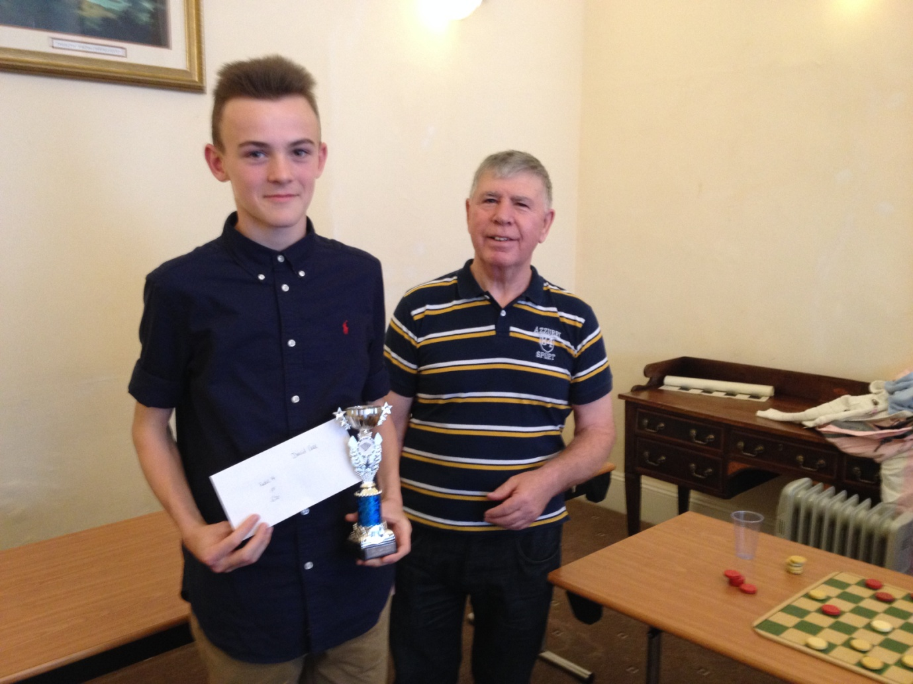

1st place presented by club treasurer Bill Dobbins to David Carr. Bill is no stranger to these young players, being involved in youth draughts from the outset, as was Jim Summers who on entering the playing room was immediately greeted by all present. Jim Having coached many young players over the years participating in the community games. To my knowledge draughts as one of the disciplines played at the community games has been an outstanding success not repeated anywhere else in Europe. The Ashbourne club has currently the under 12’s and under 10’s All Ireland medal winners.
Bill Dobbins has informed me that David Carr above will be competing in the inter section of the British & Irish freestyle Qualifier to be held in Kildare on the week-end of Feb 22nd 2015, this will be Davids first venture into a competition of seasoned campaigners and we wish him well, but i have a feeling he wont need too much luck.
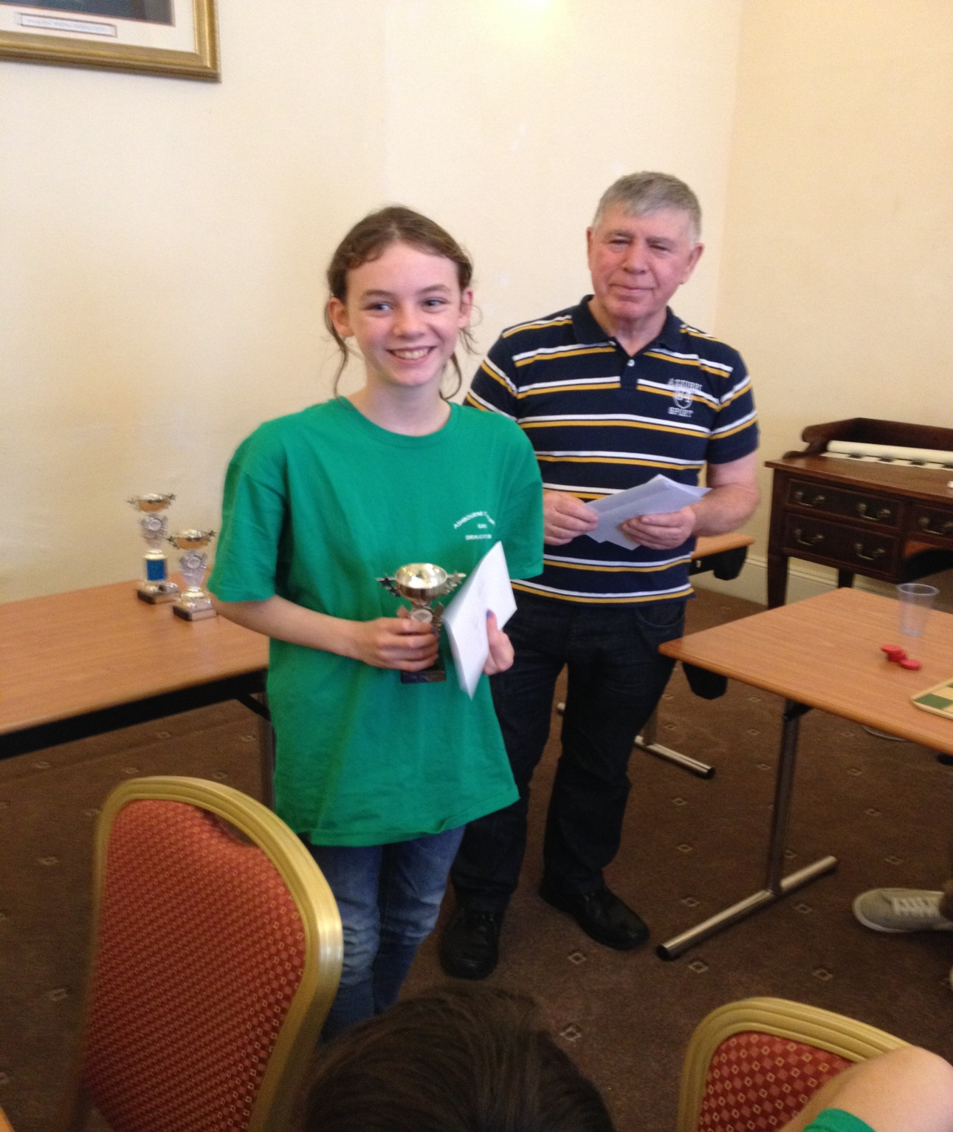

Onóra Finn (3rd)
Ireland has produced Ladies world champions, in the past with Patricia Breen from Carlow perhaps the most successful. Patricia in addition to being world champion competed in the Masters sections of many open ty’s, and represented Great Britain & Ireland in the International matches against the Americans on several occasions. It can be tough going, especially now with so many European lady players, all playing to a very high standard, but Onora is almost certainly a force to be reckoned with in the future.

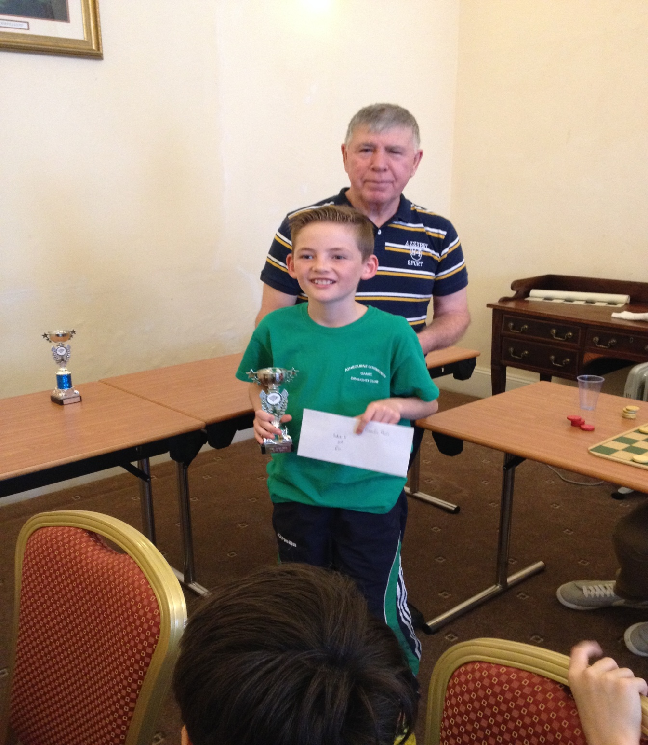
Cianán Finn (2nd )

U 10: William Carr (1st), Ashbourne,
Seán Breen (2nd) (Bennekerry)
DarraghFinn(3rd) (Ashbourne).

