Previous Winners

|  |  |  |  |
| --- | --- | --- | --- |
| 1893 | W. Bryden | 1935 | L. Claxton |
| 1894 | R. Stewart | 1937 | R. J. Allen |
| 1895 | R. Stewart | 1939 | J. MacFarlane |
| 1896 | R. Jordan | 1947 | J. Marshall |
| 1897 | J. Ferrie | 1950 | D. E. Oldbury |
| 1898 | H. Freedman | 1951 | J. Marshall |
| 1899 | H. Freedman | 1953 | J. Marshall |
| 1900 | R. Stewart | 1955 | J. Scott |
| 1901 | R. Stewart | 1961 | J. Marshall |
| 1902 | R. Stewart | 1963 | J. McGill |
| 1903 | J. Ferrie | 1965 | J. McGill |
| 1904 | J. Ferrie | 1967 | J. McGill |
| 1905 | G. Buchanan | 1969 | E. Gibson |
| 1906 | G. Buchanan | 1971 | J. McGill |
| 1907 | G. Buchanan | 1973 | W. Edwards |
| 1908 | J. Ferrie | 1975 | W. Edwards |
| 1909 | G. M. Bonar | 1977 | J. McGill |
| 1911 | J. Ferrie | 1979 | J. McGill |
| 1912 | A. Jordan | 1981 | P. McCarthy |
| 1913 | J. Ferrie | 1983 | J. Grant |
| 1914 | A. B. Scott | 1985 | P. McCarthy |
| 1915 | M. Boyle | 1987 | T. Watson |
| 1916 | G. O’Connor | 1989 | T. Watson |
| 1917 | L. Collingwood | 1991 | T. Watson |
| 1918 | A. B. Scott | 1993 | W. Edwards |
| 1919 | G. M. Bonar | 1995 | J. Grant |
| 1920 | A. B. Scott | 1997 | H. Devlin |
| 1922 | G. O’Connor | 1999 | P. McCarthy |
| 1923 | A. B. Scott | 2001 | T. Watson |
| 1924 | G. O’Connor | 2003 | T. Watson |
| 1925 | J. Campbell | 2005 | T. Watson |
| 1926 | J. Campbell | 2007 | T. Watson |
| 1927 | J. Campbell | 2009 | B. Docherty |
| 1929 | A. Inglis | 2011 | T. Watson |
| 1930 | M. Boyle | 2013 | T. Watson |
| 1931 | R. Scobie | 2015 | T. Watson |
| 1933 | A. Inglis | 2017 | S. McCosker |
| 1934 | H. French | 2019 |  |

Scottish Draughts Association

*Scottish Open*

*Draughts*

*Championships*

*June 3rd to7th*

2019

Town Hall, Broad Street, Kirkwall

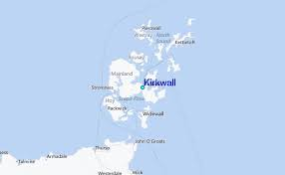

Welcome to Kirkwall

On behalf of the Scottish Draughts Association, I would like to extend a warm welcome to all players and friends to the 2019 Scottish Open Draughts Championships here in Kirkwall.

Our islands in the North of Scotland has a unique history with many interesting things to see and do.

We hope that you can take time to visit some of our many places of interest and enjoy some of the most beautiful coastal scenery in the world.

I would like to thank Harvey Johnston the Orkney Islands convener for performing his duties at the opening and closing ceremonies.

I hope you all enjoy your stay in this beautiful part of Scotland so steeped in ancient history and culture.

Lamont Inkster

(SDA President)

18 George Street

Kirkwall

Orkney

KW15 1PW

The Scottish Draughts Association has since 1892, worked tirelessly to promote the game of Draughts, not only in Scotland but throughout the world.

Organising and running a prestigious national open championship takes many hours and substantial amounts of money and this can only be achieved with the continued help and support from members, players and the outside community.

The Scottish Draughts Association has a close band of loyal supporters whose generosity makes the committee’s task of fundraising easier and we wish to acknowledge them here.

Thank you to all the following for without their hard work, donations and support this event would not be possible. The Aberdeen Draughts Club, Orkney Island Council, Donald Oliphant, Lamont Inkster, Colin Young, Graham Young, The Competitors.

If we have omitted anyone then we apologise in advance.

Donald Oliphant

(SDA Secretary/Treasurer)

16 Columbus Place

Great Sankey

Warrington

WA5 8DY

Rules

Swiss System

The purpose of the Swiss system is to determine that every player shall ultimately be placed logically and easily in ranking order of merit. After the first round the pairings will be determined by the number of aggregate points scored by each player. The Chess Arbiter programme used by the referee will determine each player’s opponent in all rounds.

1. Time Limit – 30 moves per hour, then 15 per half hour.
2. Points Awarded – 2 per win, 1 for a draw, 0 for a loss.
3. Players can only meet each other once.
4. No adjudication of games.
5. 156 openings will be included in the ballot. The player drawing the Black side will draw the opening. Both players to record the moves made.
6. If there is an uneven number of players, the last drawn will get a bye – 4 points. This will be considered to be 2 wins; only 1 bye can be given per player.
7. Tie breaking will be done by honour points. If honour points are equal, results when players met, then if still equal, least losses counts next. All rounds to be counted by honour points.
8. Any player arriving late will have the clock started against them unless prior agreement has been made between players and the referee.
9. The committee will have the power to make whatever arrangements are considered necessary to facilitate the running of the tournament and any decision they reach will be final.
10. All mobile phones to be switched off when rounds are being played. If a player’s phone rings whilst playing they will forfeit the game.

Contacts

And Useful Information

Lamont Inkster: 07759491971

Donald Oliphant: 07917132789

[Doliphant16@googlemail.com](mailto:Doliphant16@googlemail.com)

Graham Young

07946239284

Kirkwall Town Hall 01856 873354

Broad Street

Kirkwall, Orkney

KW15 1DH

Kirkwall iCentre 01856 872856

The Travel Centre [kirkwall@visitscotland.com](mailto:kirkwall@visitscotland.com)

West Castle Street <https://www..visitscotland.com>

Kirkwall

KW15 1GU

About Kirkwall

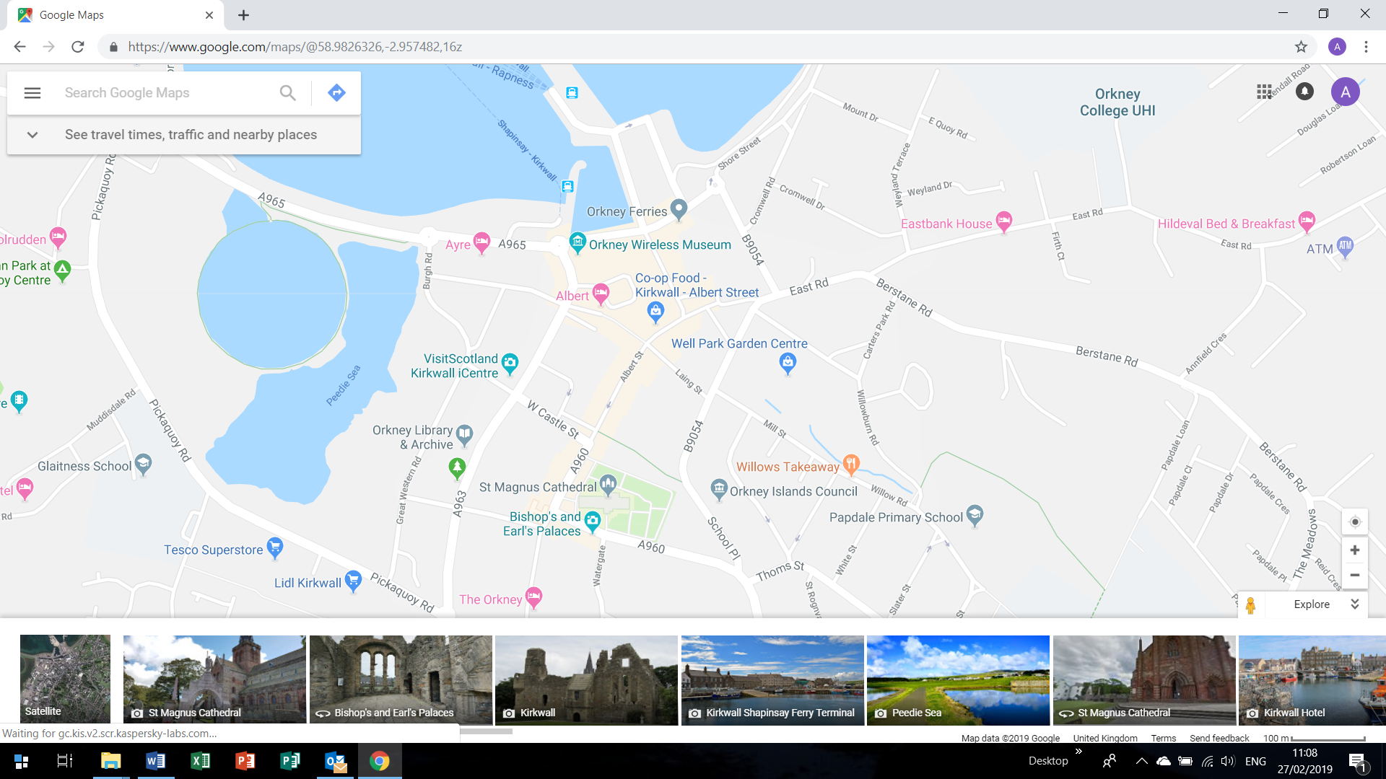

Kirkwall is a lively town situated on the largest island which is called Mainland in a group of islands called the Orkney Isles located north of the Scottish mainland.

Kirkwall has a great atmosphere and has many hotels and B & B’s.

The town becomes very busy when the cruise liners visit and the population can swell considerably. We have decided to hold the competition in June to make it easier to find accommodation ahead of the main tourist season.

The venue for the Scottish Open is opposite the St Magnus Cathedral.

Programme

Monday, 3rd June 09.30a.m. Registration and Opening Ceremony

10.00a.m. Ballot and First Session

2.30p.m. Round Two

Tuesday, 4th June 10.00a.m. Round Three

2.30p.m. Round Four

Wednesday, 5th June 10.00a.m. Round Five

2.30p.m. Round Six

Thursday, 6th June 10.00a.m. Round Seven

2.30p.m. Round Eight

18.00p.m. Scottish Draughts Association AGM

In the Royal British Legion Club

Friday, 7th June 10.00a.m. Round Nine

2.30p.m. Round Ten

17.00p.m. Prize Giving Ceremony



Est 1893