# IRISH DRAUGHTS ASSOCIATION July 2014, issue 2.

PRESIDENT : CHAIRMAN : TREASURER: Ass.TREASURER : SECRETARY : P.R.O.

Myles Hannigan, Joe McGuire, Bill Dobbins, Liam Doyle, Sean Philips, Gerald Callaghan,

Tommy Canning.

At the 2013 A.G.M held at the All Ireland in Limerick at the end of October, a letter was read by Bill Dobbins on behalf of outgoing president Mr Brendan Murray. Brendan expressed a wish to retire from the position of president of the I.D.A. This was received with both regret and an understanding of the overwhelming work and understanding that Brendan had brought to the position and indeed the game itself. On behalf of all the members we wish Brendan well on his retirement and hope to see him at the All Ireland to be held in Dublin at October 2014.

**Calendar of Events :**

Lancashire V South Wales , @ Knighton 9th August.

Northern Ireland Open 2014 @ Cookstown 4th to 6th September.

Welsh Open 2014 Knighton 20/21 September.

Czech Open 2014 Prague 4/5 October.

German Open 2014 Korbach, 11/12 October.

Irish Open2014 Dublin, 25 to 27th October.

3- move Qualifiers 2014 Louisville, KY, 13 -16 November.

**“Acknowledgements”**

*The Irish draughts Association and all its members were saddened by the passing of Charlie Devlin, Letterkenny. Co Donegal and Davy Donnell. Co Tyrone. Both men were staunch supporters of the game over the decades and our sympathies are extended to the respective families and wider circle of friends.*

**Games Section.........................**

2013 Irish Open. Bill Dobbins (R) V Myles Hannigan (W)

Tinsleys Denny. 10-14, 22-17, 11-15, 17-10, 7-14, (a), 24-19, 15-24,28-19,8-11,25-22, 6-10, 22-18, (b) 9-13, 18-9, 5-14, 23-18-14-23,27-18, 2-6 , 18-14, 10-17-21-14,6-10,14-7,3-10, (c) 26-23 to an easy draw for black. (d).

1. This Opening is covered in Tommy Cannings compilation and is regarded as one of the easier so called Barred openings. I do not believe this so. It is a fine opening and requires much detailed knowledge to negotiate the draw.
2. This 9-13 is thought to be too early, Frank Moran lost to M.Hannigan a year earlier, and Shane Mc Cosker lost the black side to A.Mosoiev.
3. At this point 32-27 was much the better option keeping black to a very narrow path to draw.
4. When i played the red pieces against George Miller, at note (b) i continued with 6-10 as per

pubLished play. 11-16,29-25, 4-8,18-15,1-6,15-11,8-24,27-11,10-15, pp to here, at this stage i was aware of the 3x3 but not the continuation. 23-18,15-29, 30-25,29-22,26-1, and now the xboard analysis began.

I have diagrammed the position but will provide no continuation at this stage, lets just say it will be instructive and of benefit to the player who studies the position initially without the use of a computer program. I did manage to draw it against George.

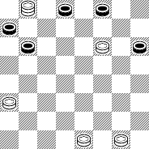

**British Open 2014 Games Section:**

2nd rd Colin Young (R) V Ron King (W)

11-16, 22-17, 7-11, 23-18, (a) 9-14, 18-9, 5-14, 24-19,16-23, 27-9, 6-22,26-17, 11-15, 17-14,

10-17, 21-14, 8-11,25-22, 4-8, 22-17, 15-18, 29-25, 11-15, 17-13, 8-11,(b) 25-21, 12-16, 14-9, 16-19, 31-26, 3-7, 9-5, (c) 2-6, 21-17, 18-22, 17-14, 22-31, 14-9, 6-10, 9-6, 10-14, 6-2, 14-17,

13-9, 1-6, 5-1, 6-13, 1-6, 17-22, ( d) 6-9, 13-17, 9-14, 17-21, 2-6, 22-25, 14-17, 11-16,(e) 28-24, 19-28,6-10,7-14, 17-12, 25-29, 12-16, 29-25, 16-19, 25-22, 19-24. (f)Drawn.

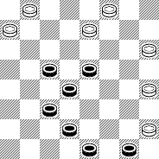

1. This transposes into 11-16, 23-18,7-11, where 22-17 now is considered a secondary line as per basic checkers. With now 3-7 given. However Wcc rates the 9-14 reply as an even position.
2. Red now strong and taking control of the centre.
3. Forms diagram.
4. At this point its a forced red win.
5. The master of combinations, and finely drawn.
6. Very entertaining for both players and onlookers.

Addie Harper (W) V Myles Hannigan (R).

10-14, 22-17,9-13, (a) 17-10, 6-15, 24-19,15-24, 28-19, 1-6, 23-18, 7-10,18-14,10-17, 21-14,(b) 3-7, 26-23, 11-16,25-21, 6-9, 31-26, 9-18, 23-14, 16-23, 27-18, 2-6, 26-23, 6-9, 23-19, 8-11, 29-25, (c)13-17, (d),(e) 25-22, 17-26, 30-23, 11-16, (f) 19-15, 7-11, 15-8, 4-11, 32-27, 16-20, 23-19, 11-16, 27-23, (g) 20-24,14-10,24-27, 10-6, 27-31, 6-1, 31-27,21-17, 9-13, 17-14,27-24. Red win.

1. Forms the Black Hole opening and well covered by Tommy Cannings Compilation, with many strong white attacks.
2. Forms position tommy recommends 11-16 at this point. And it does seem to limit white to three possible continuations, see (book).
3. Wcc rates position as drawn.
4. If 30-26, then 7-10
5. 19-15 good and lays a little trap, leave this to the reader to sort out.
6. 32-28, wcc database draw.
7. Any other move and white draws.
8. Addie Harper played extremely well in this his first masters ty. Drawing the second game against Myles, and scoring a 3-1 result over Danny Oliphant In the next rd.

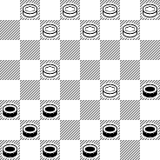

Rd 6 Game 2 M.Hannigan (R) V Ron King (W).

9-13, 22-17, 13-22, 25-18, 11-15, 18-11, 8-15, 24-20, (a) 4-8, 21-17, 5-9, 17-13, 9-14, 29-25, (b) 14-18 (c) 23-14, 10-17, 27-23,6-10, 28-24, 15-19, 24-15, 10-19, 23-16, 12-19, 25-22, 8-11, 22-18, 16-12, 26-22, 3-7,22-17, 1-5,18-14, 6-10, 32-28, 11-15,20-16, 19-24, 28-19, 15-24, (d) 16-12, 24-28, 12-8, 28-32, 8-3, 32-28, 3-8, (e) 28-24, 8-12, 24-19, 31-26, 19-15, 12-16,15-11,16-19, 11-8, 26-23, 8-3, 19-24, 7-11, 14-7, 3-10, 23-18, 11-16, 18-14, 2-7, (f) 24-20, 16-19, 20-16, 19-24, 16-11, 7-16, 14-7,16-19, 3-7, 19-23,3-7, 24-27, 7-10, 27-31, 17-14, 31-27, 10-7, 23-26, 30-23, 27-9, 13-6, 5-9, 7-10, 9-13, 10-14, 13-17, 6-2, 17-22, 14-18, 22-26, 2-7, 26-31, (g)

1. This is not given in B.C or Kears Ency, typical of Rons play.
2. However at this point we are now on p 395 @12th move , just a different order.
3. This is mentioned in Kears but with no continuation, seems to be sound.
4. Wcc rates the position even. But of course ron has his eye on an ending.

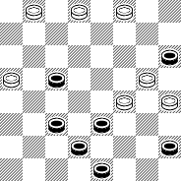

1. At this point i looked at 7-11, but felt that Rons kings were much more active , heading for the same type of ending.
2. Disgusted with myself for allowing the tie.
3. My final move. Perhaps lucky to draw the ending.

**Report on the 2014 British Open :**

**“Ron King wins 2014 Open”**

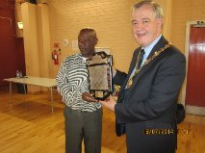

**The 2014 British Open. 14th July to 18th July Report form a playing / visitor.**

On arrival at the playing venue, The Spectrum centre in Inverness city, it was as i remembered it from 2010. A well light and airy room with the players well spaced out. Everyone received a booklet On arrival, simple in its outlay and all the more a delightful collectors memento. I hadn’t realised that Shane McCosker was going for three in a row titles. This was only surpassed by J.Marshall in 1948,50,52 and 54. As always the standard of play is tough at this event and when Ron King decided to play, the stakes just got higher. It is a privilege to have the ten times World champion and as Alex Mosievey described Ron “ The champion of the 20th Century”seated across the board from you.

The ty was refereed by Graham Young, as well as playing in the Senior ty. Smoothly and efficiently run , on behalf of all the players thanks Graham.

With two rds per day, a 10.00 am start and 2.30 pm, we were usually finished up by 6.00 pm.

The players would usually head to Witherspoons, and after the food a few drinks the post-mortems would begin, and end with a good laugh. Inverness is more like a very large town, and there were many sights to see , and very pleasant walks, of course the weather was incredible.

By rd 5 Ron had extended his lead by two pts over Shane, and although i managed two draws as did Shane with Ron, he went on to establish an unassailable lead. The standard of play was extremely high and i continually kept an eye on the other boards during play. At the moment i have sent 7, diagrammed and annotated games to Graham and these should be available on the Scottish Draughts web page. I believe all players will find them of some interest The presentation was held at 5.00 on the Friday evening and loads of photographs were taken and can be seen on the same site. The prize money was very good and thanks to the Inverness Common Good Fund via The Highland Council. I personally acknowledge lamont Inksters contribution, and all the assistance he received from Danny Oliphant and the Young Family.

Congrats to all the prize winners and Lamont Inkster winning the Senior and Ron King the Masters.

The ty was officially closed by Alex Graham, Provost of Inverness.

There is talk of the next British Open taking place in Wyck, but yet to be confirmed. .

Snapshots of the Open:

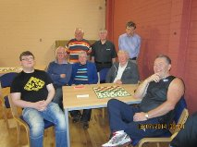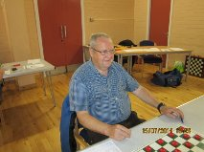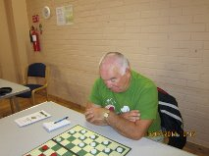

S

s.McCCosker, M.Hannigan, ots of the Open 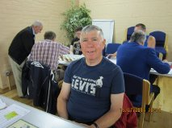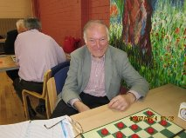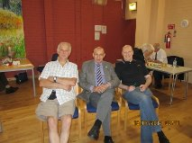

tT Ts s

T

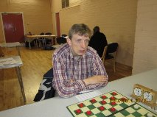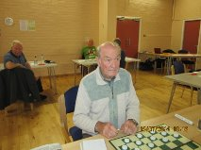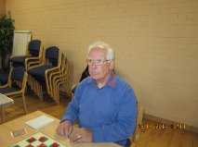

Top L-R : S.McCosker, F.McNally, F.Moran, Con.Boyle, S.Phillips. J.Jolliffe, C.Baikie.

IMPORTANT, IMPORTANT, IMPORTANT, IMPORTANT, IMPORTANT, IMPORTANT, IMPORTANT, IMPORTANT,

**The 2014 Irish Open Draughts Championships.**

The IDA would like to welcome our friends from Ireland and abroad, to this unique event, which will be held in the centre of Dublin City. The venue is the Beresford Hotel in Store Street and Beresford place and is a three star hotel.

(08134700) (0035318134700). Thedate is 25/26/27.October 2014.

The main train station from the north (Connolly) s across the road from Heuston train station. Just hop on to the Luas, to the central bus station (Busaras) which is opposite the Hotel. So no matter where you ar oming from it could not be more convenient. People coming from the airport can take the public bus which will leave them a couple of minutes from the hotel.

The cost of a double room is just 70 euro per night, a single is also the same price,and includes breakfast.

Every room is ensuite, telly, tea, coffee, etc. However the committee must point out the importance of booking your room as soon as possible. As we have made a good deal with them. Normally it is 100 euro per night, so in fairness to them and us it is important to measure the level of bookings. This is also the holiday week-end and accommodation will be heavily booked. So don’t be disappointed and make your booking now.

Parking in town is not cheap, there is however a concession when staying at the hotel-24 hour parking for 12 euro, ticket has to be validated at the hotel reception. In addition to our main event there will be a children’s event on the Sunday. Held in the Beresford suite and we look forward to the children and parents participating in this event in the nice Georgian building which is a corridor away from Anna Livia room where the main event will be held.

This is an extract from the letter written by Joe Maguire-Chairman, Irish Draughts Association. Taken from the excellent Kildare Newsletter produced by Bill Dobbins, and with their kind permission.

Over the last decade the numbers attending National Tournaments have dwindled. This year the Tournament will be run over 3 days. Two (rds) Saturday, and AGM at night. 3(rds) on the Sunday. Two (rds) Monday and final Presentation. This adds up to a three nights staying over, with ample time to complete homeward journeys as it is expected to have concluded the presentations by 6.00 pm.

This is an attempt to attract more players. Expenses have been kept to a minimum, as have any holiday from work requirements. Time will tell if it has been successful. Please give your support and it will.

In addition each days play on completion, results and leaderboard updates and a couple of games (annotated)will be posted on the Scottish.D.A, and Irish.D.A websites in addition to the American Checker Forum.

Myles Hannigan, editor.